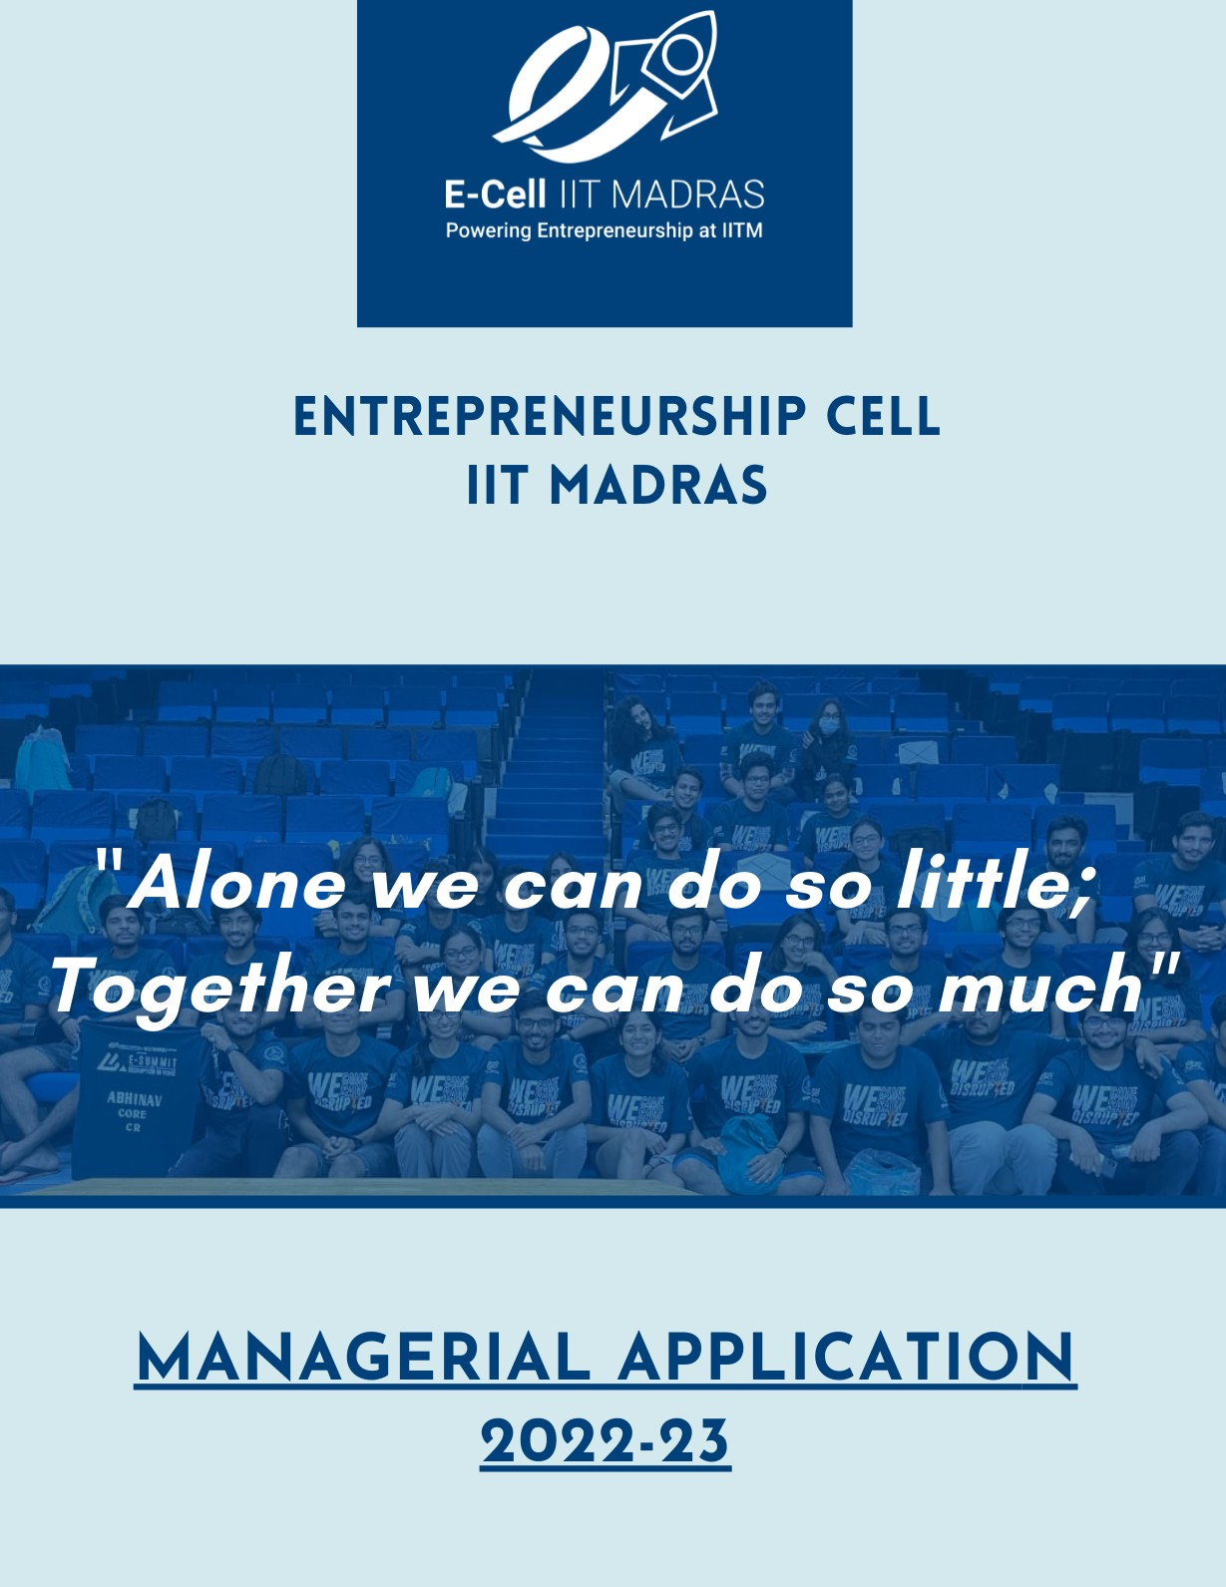

|  |  |  |  |
| --- | --- | --- | --- |
| **Name: Amol Agrawal** |  |  | **Insti-Name: Amol** |
| **Roll No: NA21B006** | **Room No: 808** | **Hostel: Mandakini** | |
| **Phone: 6306160073** | **CGPA: 7.25** | [**Email: amolagrawalofficial@gmail.com**](mailto:amolagrawalofficial@gmail.com) | |

Application | Managerial Team 2022-23 **0 3**

E-Cell_Manager_2022_WMO_Amol Agrawal_NA21B006

**GENERAL QUESTIONNAIRE**

**EXPLORING ENTREPRENEURSHIP AT IIT MADRAS:**

1) Nowadays the environment has changed. Unlike our previous generations, instead of taking a job our students wants to give a job, being an entrepreneur they want to give back to the society and to help them in this regard, E-Club was set up in the year 1998, with its former name being Centre for Technological Innovation, Development & Entrepreneurship Support (C-TIDES), which has not only guided the students of IIT Madras but also the students of many Indian colleges with programmes like Entrepreneurship Development Drive (EDD), Pitch Perfect, E-Insider, Suspire and many more. It has also nurtured some of the best start-ups like Hyperverge (software tool for identity verification as security concerns), Detect Technologies etc.

In addition to their achievements, I expect E-Club to instil a thought in the mind of our students that instead of ‘taking’ a job, they must think of ‘giving’ a job & this is only possible if they get out of the fear of any losses and with E-Cell’s help they strive hard to work as an entrepreneur.

To work effectively and help students in all the fields, E-Cell is further divided into its 11 verticals which are:

Student Relations & Outreach: It strives to build healthy relations with IITM students & the outside world. It also runs EDD throughout the country.

Web & Mobile Operations: This is only the body which is responsible for making and designing websites and apps for all the events of E-Cell.

Corporate Relations: This body is responsible for developing E-Cell & E-Summit as a brand in the corporate world. Along with that it

also brings sponsorship deals for E-Cell’s yearlong initiatives.

Development & Association: This body is responsible for the quality of the events of E-Cell. As the name suggests, it also maintains associations with other bodies to conduct events and grow together.

Entrepreneurship Club: This body is responsible for detoxicating the minds of students from all myths around entrepreneurship through inter hostel competitions, Case study competitions, interactive sessions like Ask Me Anything and much more.

Editorial & Research: It is the content creator of the E-Cell. They interview and interact with the leading entrepreneurs and help students with their experiences. The annual flagship magazine of E-Cell, E-Insider is also created by this body.

Events & Networking: This body is the one which shapes a student to be an entrepreneur. With events like Pitch Perfect, Inspirit, etc. it inculcates startup fundamentals, foster ideas with knowing the market trends and helps in developing the user innovation mindset.

Finance & Operations: This is the backbone of E-Cell and its events. Along with catering to all the financial needs of E-Cell, it also plans and manages events, catering stalls, merchandise to be sold, etc.

Graphic Design & Media: They are the content presentators of the E-Cell’s events. They ideate and create posters for E-Cell, takes care of media part of E-Cell initiatives and is responsible for waste management and infrastructure planning.

Marketing & Public Relations: This body is responsible for the digital marketing of E-Cell. It also campaigns, makes PR deals and stunts, etc.

Startup Services: As the name itself suggests, they are responsible for helping and guiding students with ideas for successful operations of a startup. They collaborate with research organizations, big companies, universities, entrepreneurs, investors, etc. and support students with all their needs related to the startup world.

2) Two entrepreneurship promoting bodies within IIT Madras aside from E-Cell are:

(a) IITM Incubation Cell: IITMIC is responsible for giving a greater push to the entrepreneurship at the institute through experiences. It promotes innovation-driven activities at the institute and provide the necessary support to help the beginner entrepreneurs survive the competitive market.

(b) Centre for Innovation (CFI): It strives to build the technical skills of the students. It provides students with a necessary platform for realizing their ideas. It organises several events, workshops and initiates projects making use of which students get ample of guidance here from the faculties and senior students.

### GETTING TO KNOW YOU:

3) Owing to my deep interest and enthusiasm in developing websites, making its frontend bold and unique, adding superior functionalities in it for more user-friendly experience etc., I would like to be a part of Web & Mobile Operations. Being a part of it will also help me to learn app development, gain experience in website operations, work on several projects and most importantly it will give me an opportunity to work for the E-Cell along with a team, adding to my teamworking experience.

4) As a diligent and an optimistic guy, I have been always taught to work religiously irrespective of what the results could be. Owing to my commitments in the past, some of my skills are:

(a)Web Development: I know HTML, CSS through which the frontends of a website are designed. Apart from this, to hone my skills, I’m on my way to learn JS, Node.js, React.js etc. Being an enthusiast of it, I would like to learn a lot more from E-Cell in the field of designing interactive, user-friendly and responsive websites.

(b)Git & GitHub: Nowadays developers require ideas and guidance to make their codes more efficient, interactive and unique. Therefore, I have also learnt working with Git & GitHub to interact with other developers & work in a collaborative manner.

(c)CPP Programming: I have a great enthusiasm in the field of programming and developing software.

Hence, I’m learning C++ and on the verge of completing it.

(d)Social Media & Travel: Being an active member on leading social media platforms and a hodophile, I like publicizing things and advertising for them. After learning video & image editing, I’ll try to be a member of the Publicity unit of our annual fest Shaastra.

Apart from the aforesaid skills, I have great interests in learning things like machine learning (ML) and projects based on it, data science, data visualization, mathematics, consulting, finance, marketing, developing projects based on ML, APIs and data extraction from it etc. I will definitely learn them in future to increase my skills.

I also have an idea of a project, namely Travel Manager, which is based on programming, web development and APIs. In brief, this project will show the list of all the trains and flights (simultaneously) available between the two places and sorts them in the increasing order of their prices which includes all the schemes and benefits available and the users can book their tickets comfortably at a single platform after pondering upon the prices of

both the trains and flights at a single platform. There would be certain more utilities in it which will make it unique, bold and user-friendly.

### 

### RESPONSIBILITY OF POSITION:

5) Some of the key roles and responsibilities of WMO are:

(a)To deliver the required websites and apps for events of the E-Cell. Websites of E-Summit, EDD, Pitch Perfect etc. are the ones designed by WMO.

(b)To check the security and functionality of E-Cell & E-Summit websites from time to time and keep it updated.

(c)Managing SEO of the E-Cell & E-Summit homepages are the key responsibilities of WMO specially in the current competitive scenario.

(d)Proper maintenance of Institute portals like portals for startups, students and professors so that they must not fail to work at the time of requirement.

A WMO manager is an important position in any vertical of E-Cell and therefore some key roles & responsibilities lie on the head of the designated person, which includes:

(I) Delivery of the required products like portals, landing pages etc. at the specified time.

(II) A manager is the front face of any project hence it has to take ownership of the tasks given to him.

(III) Rather than forwarding any problem, it’s the sole responsibility of the manager to tackle and solve it in a timely manner.

(IV) Just like the selection of managers, AMs (assistant managers) are also included in WMO for its proper functioning. Their selection in a free, fair and unbiased manner is also a prime role that a manager has to play.

In the upcoming future I would like to start an initiative whose prime focus would be to make students comfortable with ‘advanced’

web development so that instead of copying codes from multiple sites all the time they can simply use their outstanding skills and experience to build websites with advanced functionalities, boldness, user-friendliness, attractiveness and uniqueness.

Implementing this on land will require certain steps like:

(I)Selection of students who are really very serious with it and want to be the ‘masters’ of web development.

(II)Organizing sessions on weekends and some holidays to facilitate their learning.

(III)Starting several projects and making them their part so that they can put that on their resume after completion.

(IV)Offering certificates from the E-Cell WMO on their successful skill gaining.

(V)Making them familiar with the importance of web development and career aspects of the same.

Application | Managerial Team 2022-23 **0 3**

## TEAM SPECIFIC QUESTIONNAIRE

## Project: <https://amolpriceless.github.io/WMOapplication/>

## Repository: <https://github.com/amolpriceless/WMOapplication>

## TECHNICAL QUESTIONNAIRE:

 It is crucial for every organization to interact with its user to improvise themselves (or their policies) using their opinion. Hence it becomes important to build an effective system for a body’s interaction with its users.

Customer Relationship Management (CRM) is a process in which several businesses, institutions, or other organizations administers its interactions with their customers or users to collect large amount of information.

Some of the prominent companies using CRM are:

Apple: CRM plays a crucial role in Apple’s growth strategy. After registering the apple device with unique apple id, the user gets separate recommendations based on what they like. It is a tool that provides detailed information about what customers like, thereby reaching the target easily.

Coca Cola: CRM is used by Coca-Cola to promote cooperation and solve customer problems quickly and effectively. CRM software enables every member of the Coca-Cola team to identify problems,

track customer behaviour, and social media to drive incentives.

Amazon CRM: Over the past few years, Amazon has become the key online platform for online shopping, and the CRM system is one of the main reasons for this. Amazon has one of the most complete CRM infrastructures in the world that harnesses customer data during purchases to instantly customize users’ online experience.

According to me, E-Cell IITM should have a CRM of its own. A CRM system will help E-Cell to improvise its policies and working based on students’ feedback or review. It will also help E-Cell to increase its audience and guide the aspiring entrepreneurs in a more efficient manner.

Some demerits of the given UI are:

1)Too much content is displayed on the homepage itself which is not a good practice. They could have created a separate “About Us” section for the same.

2)Less contrast: Instead of using only 3 colors (blue, black & white), they can add more colors to make it bold and a nice animated background conserving the context of the product they are selling.

3)Old-fashioned: With normal font type, blurred images and a simple white background in the lower part, the website looks dumb which could be cured using some new and emerging UI trends.

Some improvements that we can make in our E-Cell’s homepage are:

1)Dull background: Instead of a colored video, in the background, adding a non-colored video with less opacity and the texts in

darker colors, will increase the boldness of the website.

2)On observing the E-Cell website of IIT Bombay (<https://www.ecell.in/2020/#home>) we will come across a separate section for NON-IITB students, which is absent in our E-Cell’s website even after E-Cell IITM works for outsiders too. We should work on this.

3)Although there’s a separate section of “Contact” available on the website, one phone number, email id and logos of several social media platform is given on the top left and right corner. It’s not good to repeat things on a single page.

4)In the lower part of the website instead of a random background we can add photos of E-Cell events and initiatives to let the user get an impression of our on-ground presence and reality.

**TEAM SPECIFIC QUESTIONNAIRE**

### TECHNICAL QUESTIONNAIRE:

### Some steps to increase SEO of E-Cell & E-Summit’s websites are:

### 1)Relative and authoritative content: Along with other members of E-Cell WMO and other verticals, I’ll research about the keywords or the phrases which is largely used by the users on the search engines and consider including them in the website.

### 2)Mobile friendliness: Nowadays 70% of google searches come from mobile phones according to some recent studies, hence I will consider making websites of either of them as responsive as possible to increase the web traffic and in turn the SEO.

### 3)Decrease load times: Will try to use certain software which detect the speed of the website and tells about some odds which we might be able to improve.

Application | Managerial Team 2022-23 **0 3**

## TEAM SPECIFIC QUESTIONNAIRE

### TECHNICAL QUESTIONNAIRE:

 Steps to ignore tracking any python (.py) file or folder are:

Step 1: Create a *.gitignore* file using “touch .gitignore” command.

Step 2: Add the file/folder name to be ignored from tracking in the *.gitignore* file.

Step 3: Add *.gitignore* file in git repository and commit changes.

Step 4: Running the command **“***git rm –cached* ***filename****“*

*At last we can check using “git ls-files” command that the concerned file/folder is not present in the shown list.*

*Also when I tried to add new.py file in git repo after following the above steps with it then the control tells that it is ignored:*

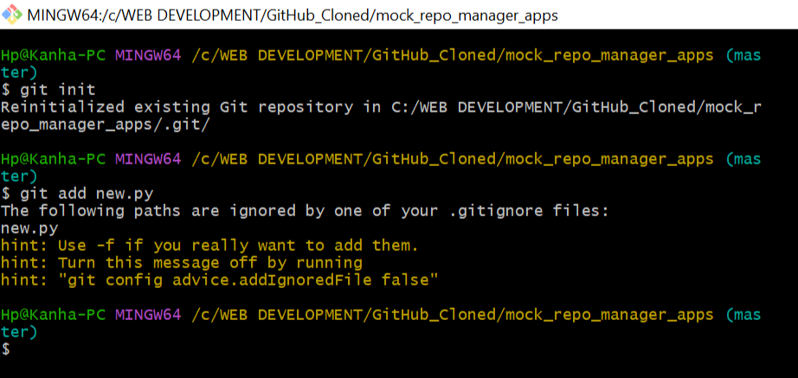

 Created a **branch** named as amol, published it to the fork, and also made a PR.